**How to Generate Tokens in LocalHost Using JMeter:**

**Step:1** Open the **JMeter Tools**. Test plan screen will showing.

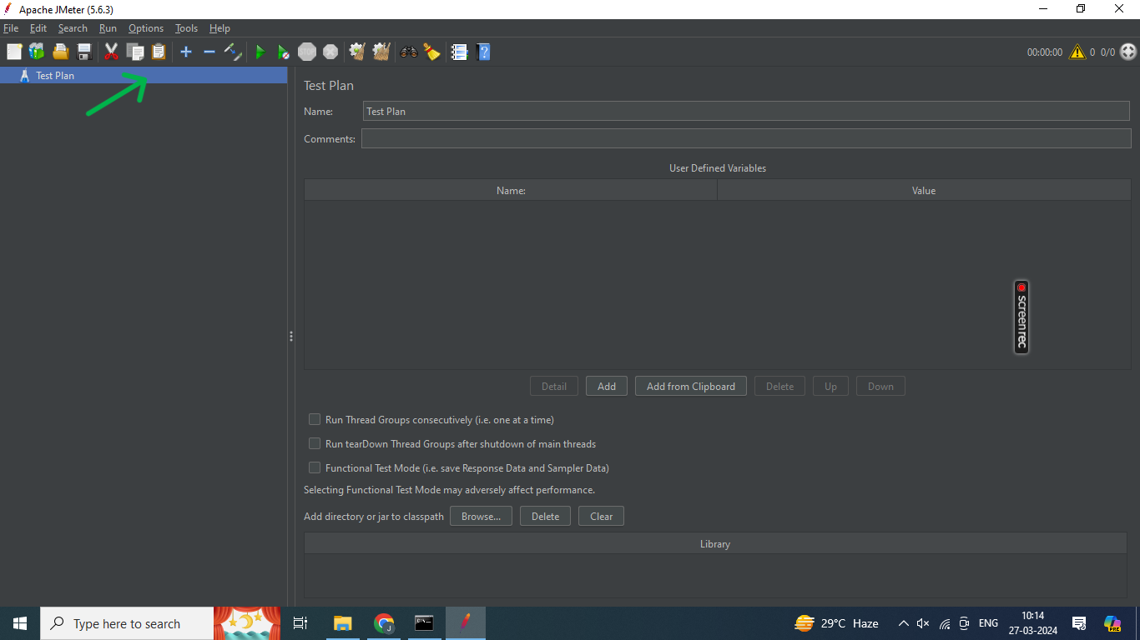

**Step:2** Right click the **Test plan.**

**Step:3** Go to add, then go to T**hreads (Users) and select Thread Group** and Thread Group will created.

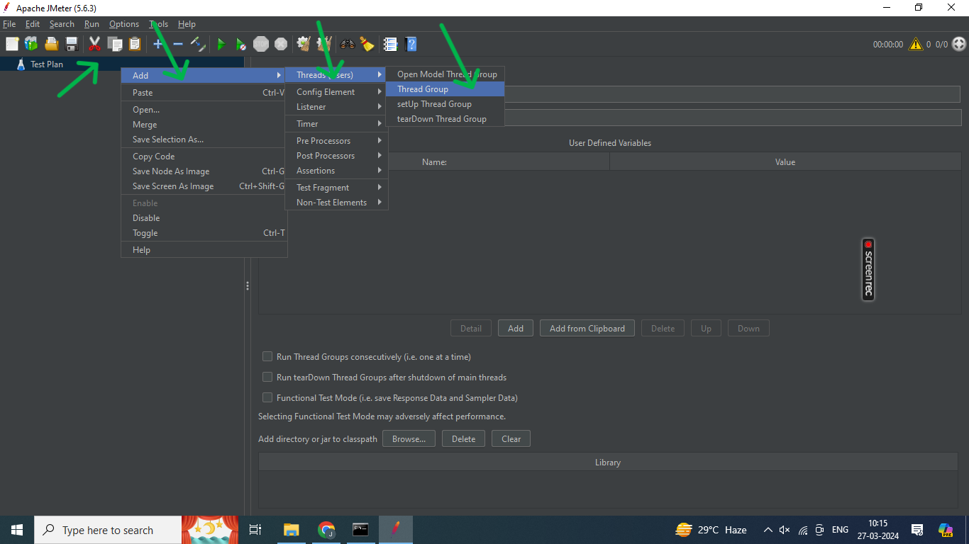

**Step:4** We are adding the **Number of Threads, Ramp-up period in seconds and Loop count or Infinite values**.

**Ex:**

Number of Threads (Users) = 1

Ramp-up period in seconds = 1

Loop count = 1

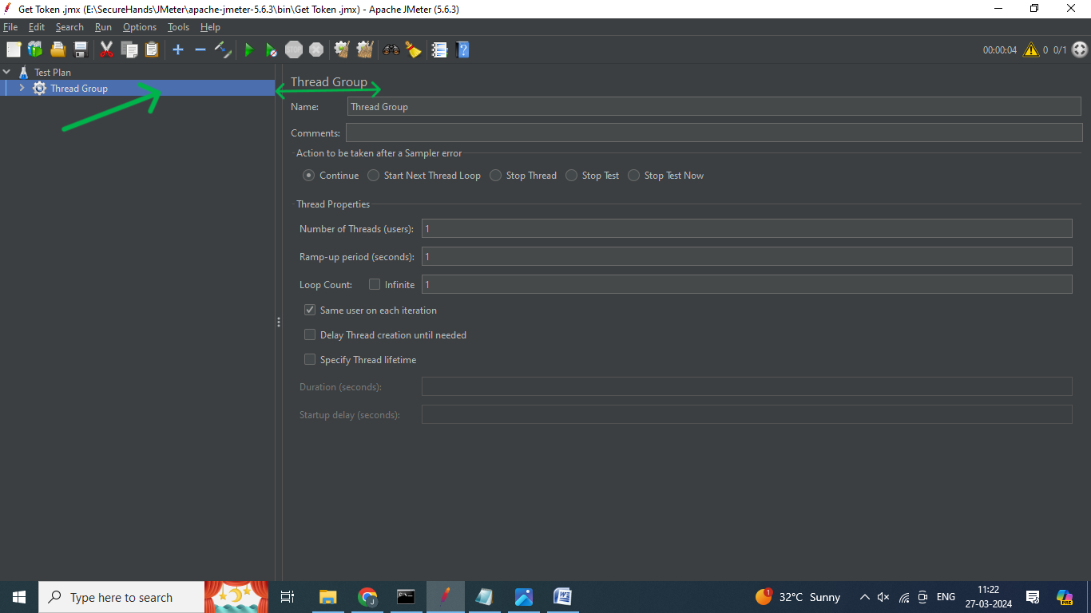

**Step:5** Right-click on the **Thread group**, go to add option and go to the **Config Element** option

**Step:6** In the menu that appears, select the **HTTP Header Manager option** andHTTP Header Manager will be created.

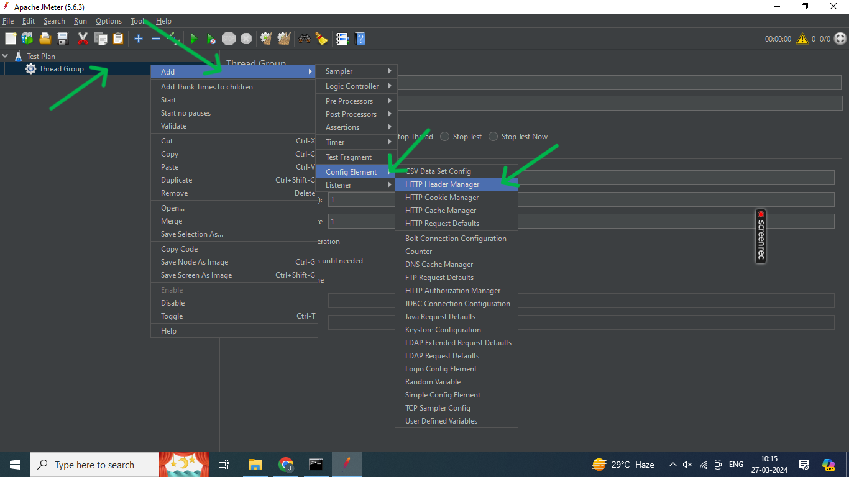

**Step:6** Click the **add button** in two times.

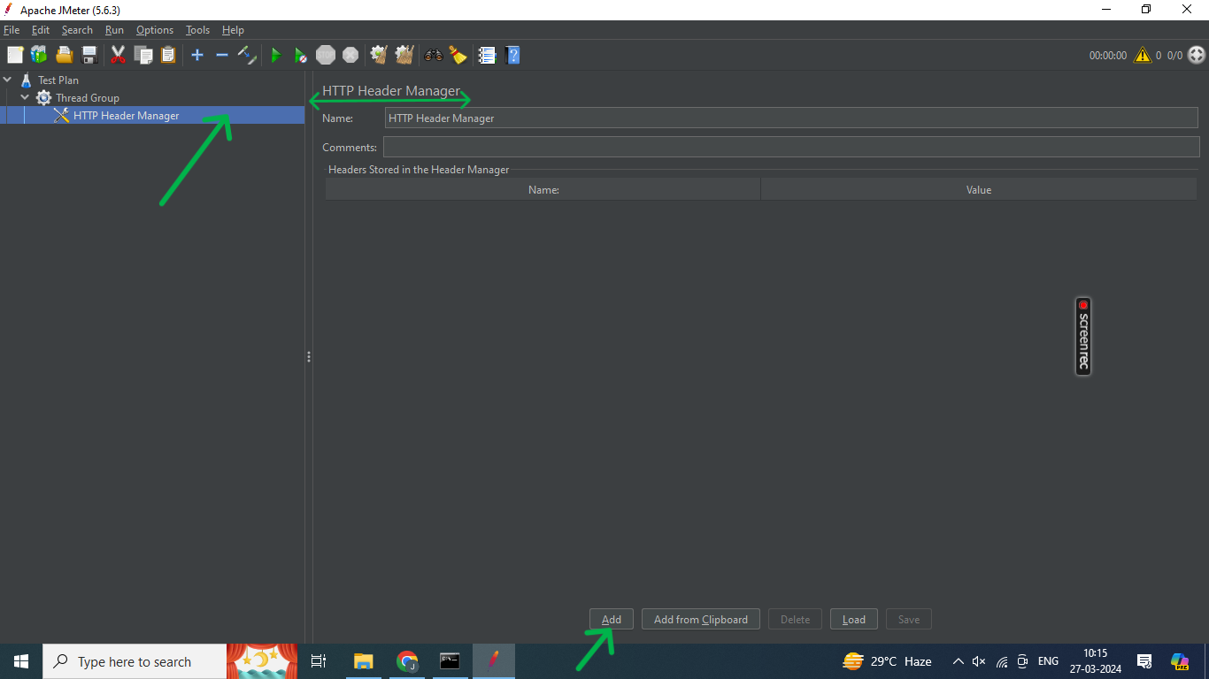

**Step:7** After Enter the **Header Name and value.**

**Ex:**

**Name - Value**

Tenant <Your Tenant Name>

Content-Type application/json

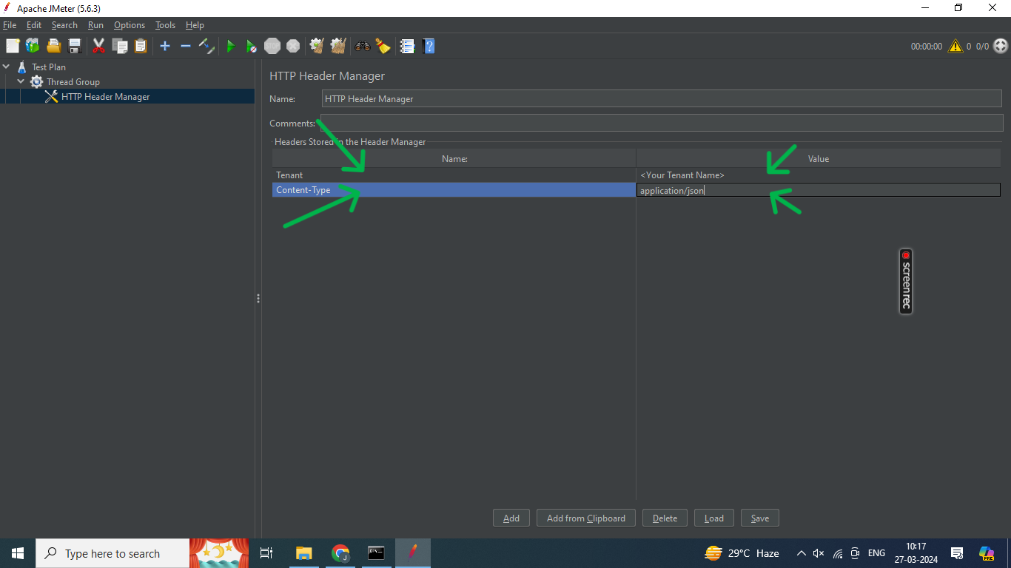

**Step:8** Right-click on the **Thread group**, go to add option and go to the **sampler** option

**Step:9** In the menu that appears, select the **HTTP request option and** HTTP Request will be created.

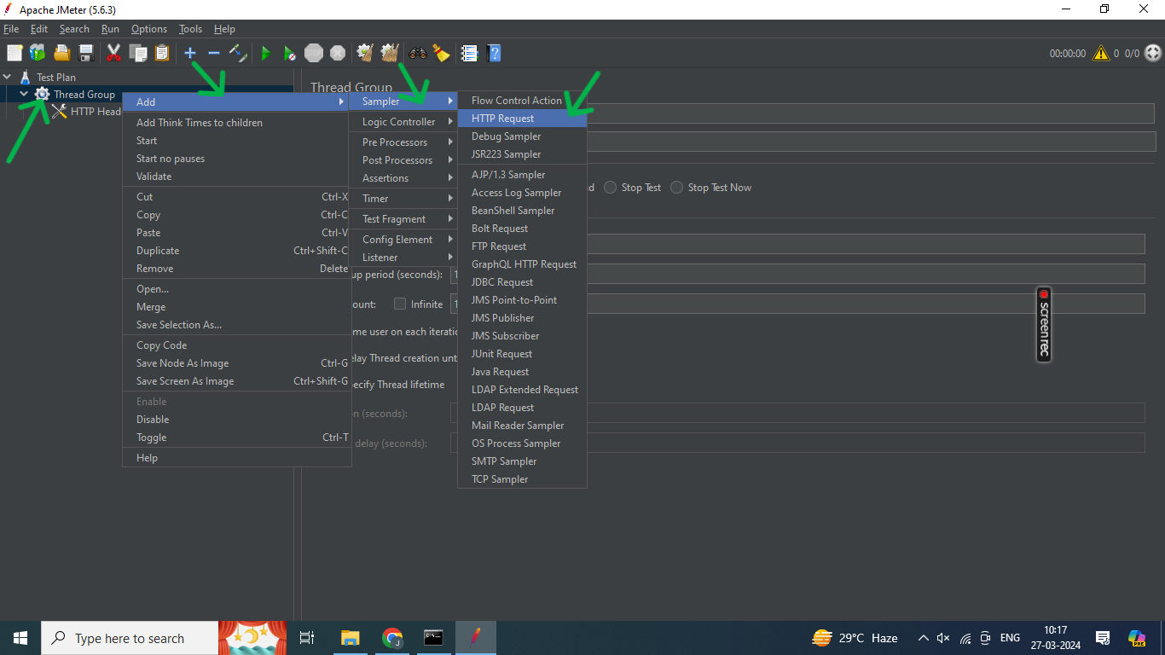

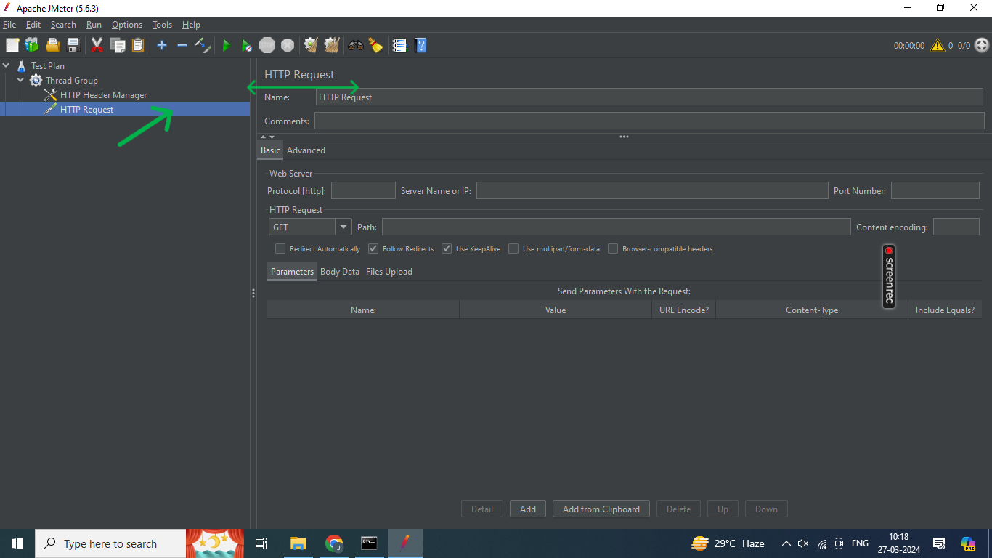

**Step:10** First think this we are **run the API localhost.**

**Step:11** After click the **Token method.**

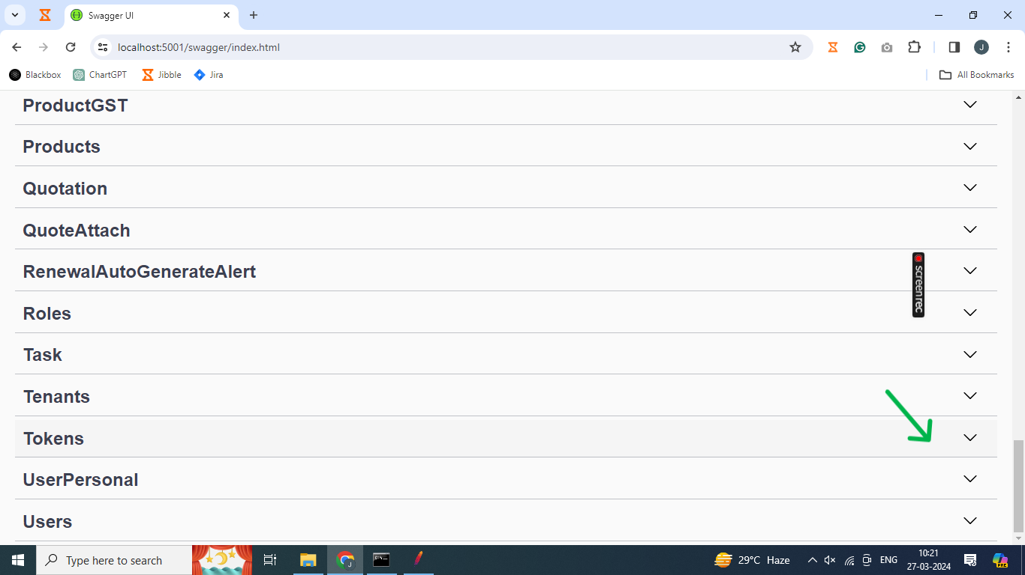

**Step:12** Click the **Post method.**

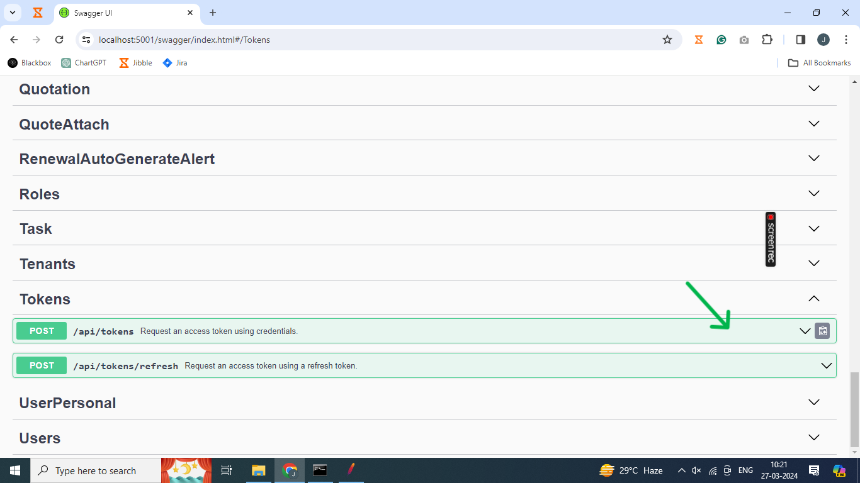

**Step:13** Click the **Try it Out button.**

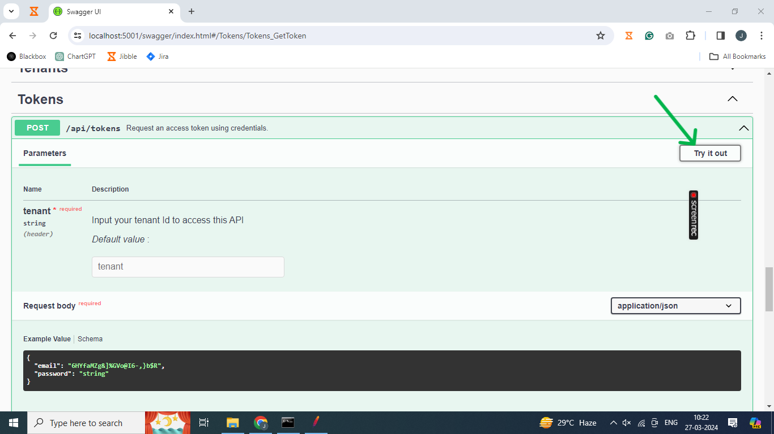

**Step:13** After enter the **<Your Tenant Name>.**

**Step:14** Request body we are enter the **<Your Email Id> and <Your Password>.**

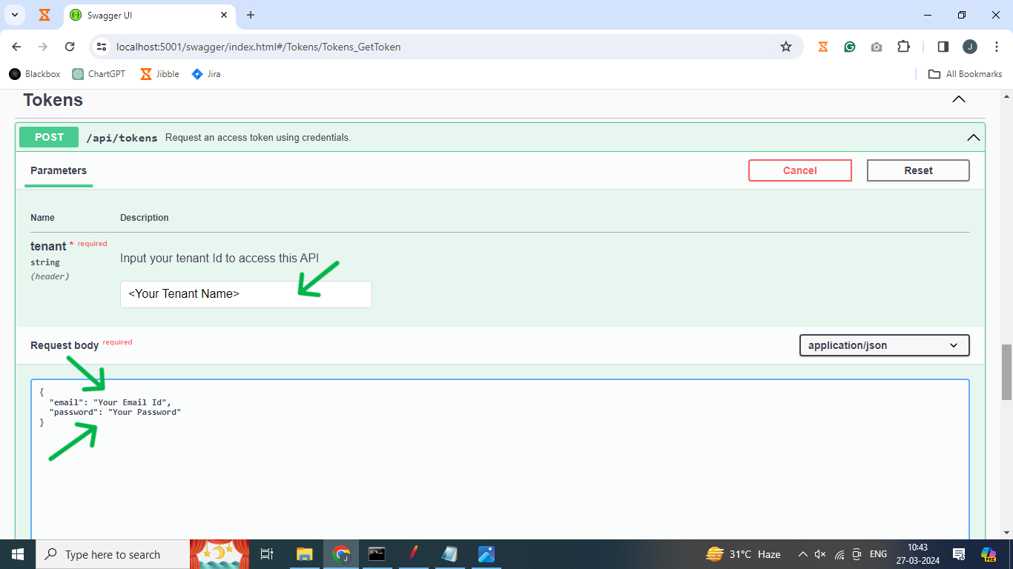

**Step:15** Click the **Excute button.**

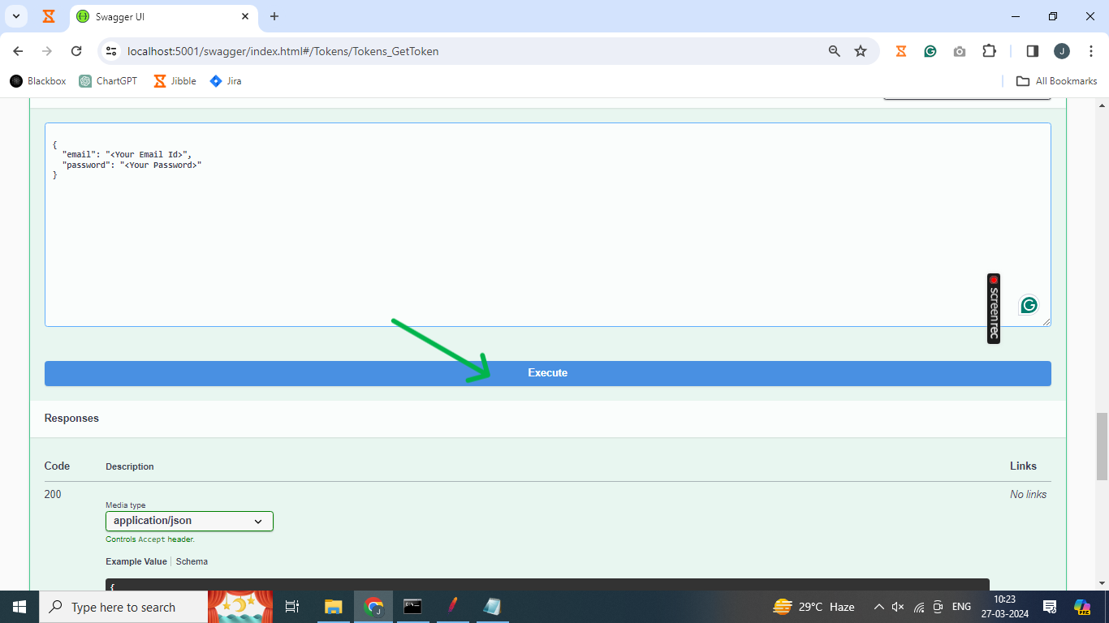

**Step:15** After Copy the **Request URL**.

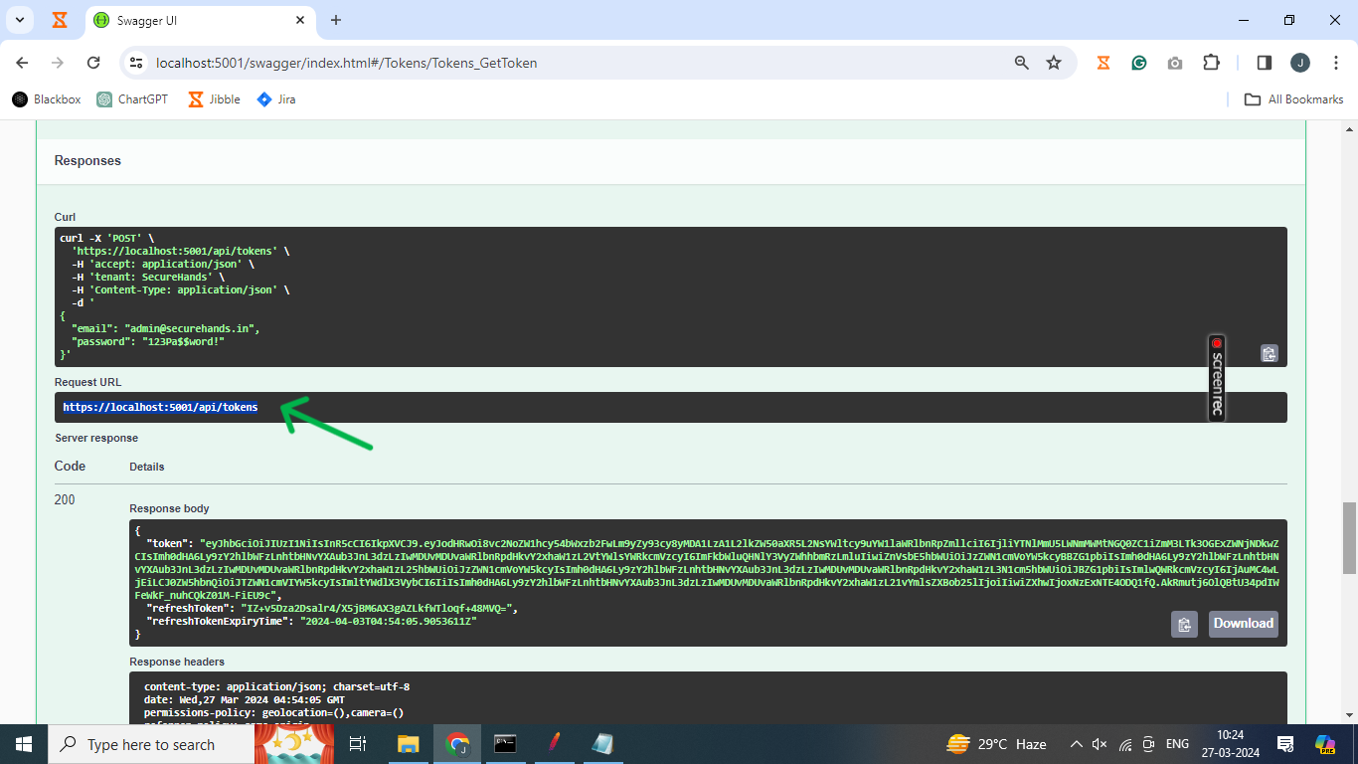

**Step:15** Copy the Url and paste the Marked field as given in the below example.

Ex:

Protocol[http] – https/http

Server Name or IP – localhost

Port Number – 5001

HTTP Request – Post,Get,Put,Delete

Path – /api/tokens

Content encoding – utf-8

**Step:16** Body data we are enter the **<Your Email Id> and <Your Password>.**

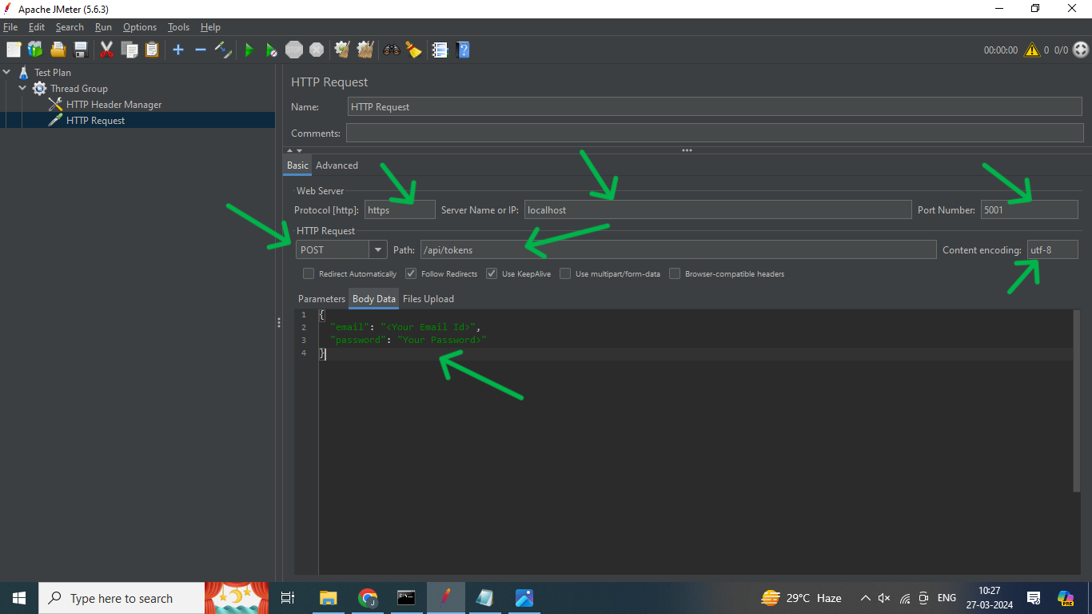

· **Step:17** Right-click on the **Thread Group.**

· **Step:18** Go to Add, select the **Listener option**, and go for the **view Results in Tree**

option

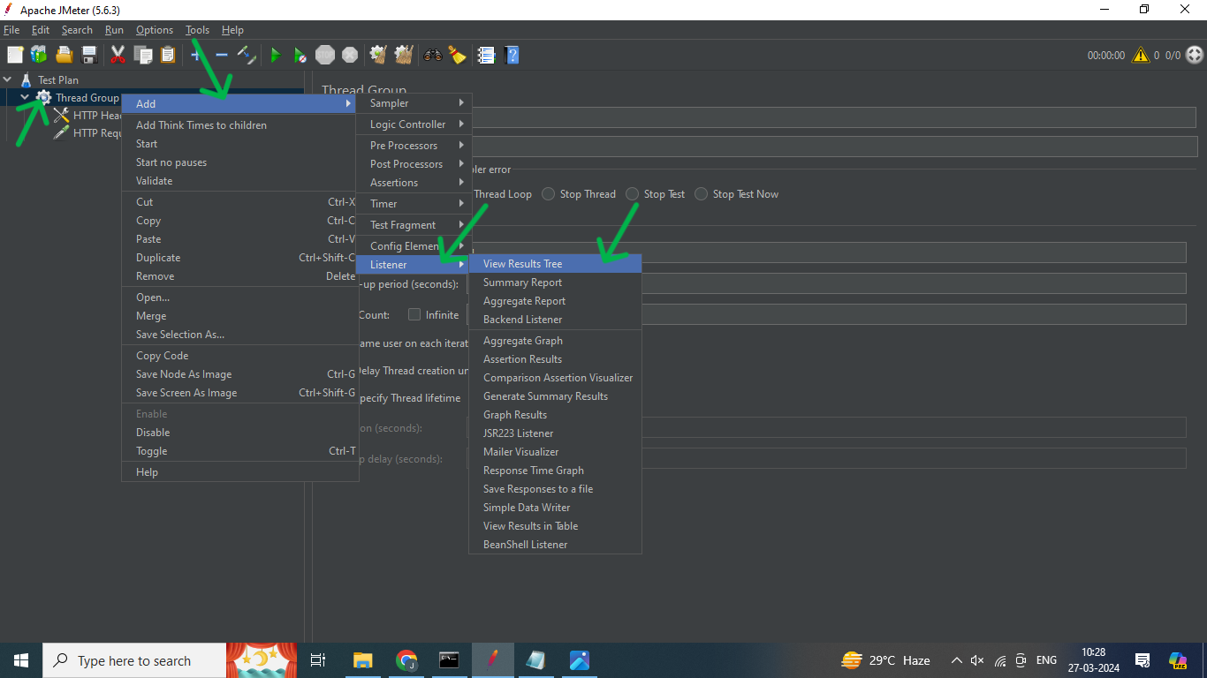

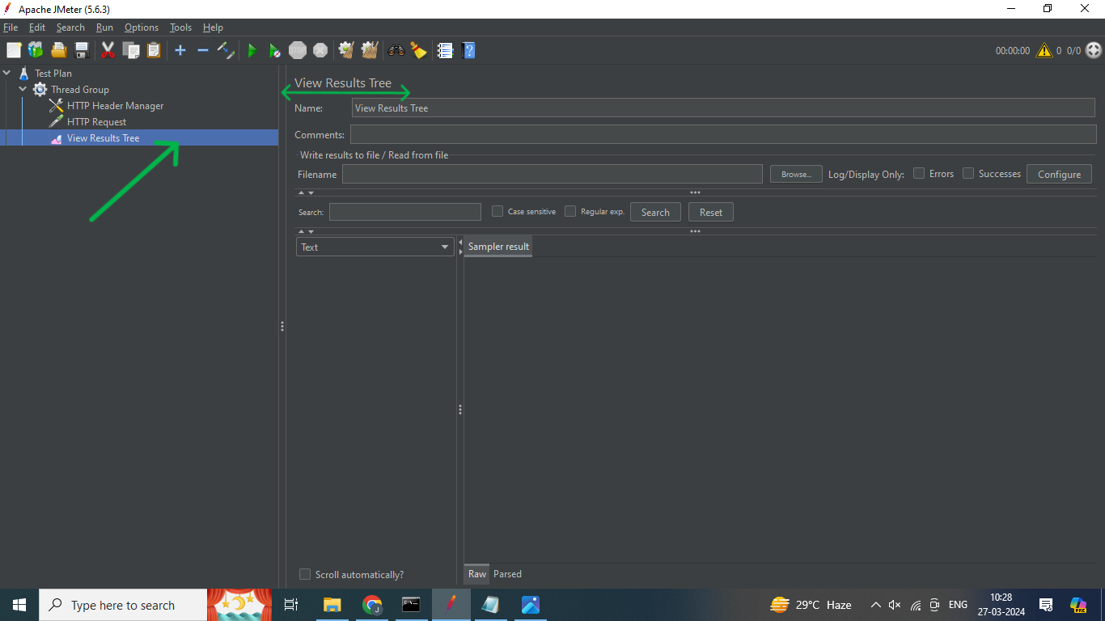

· **Step:18** Save this JMeter test

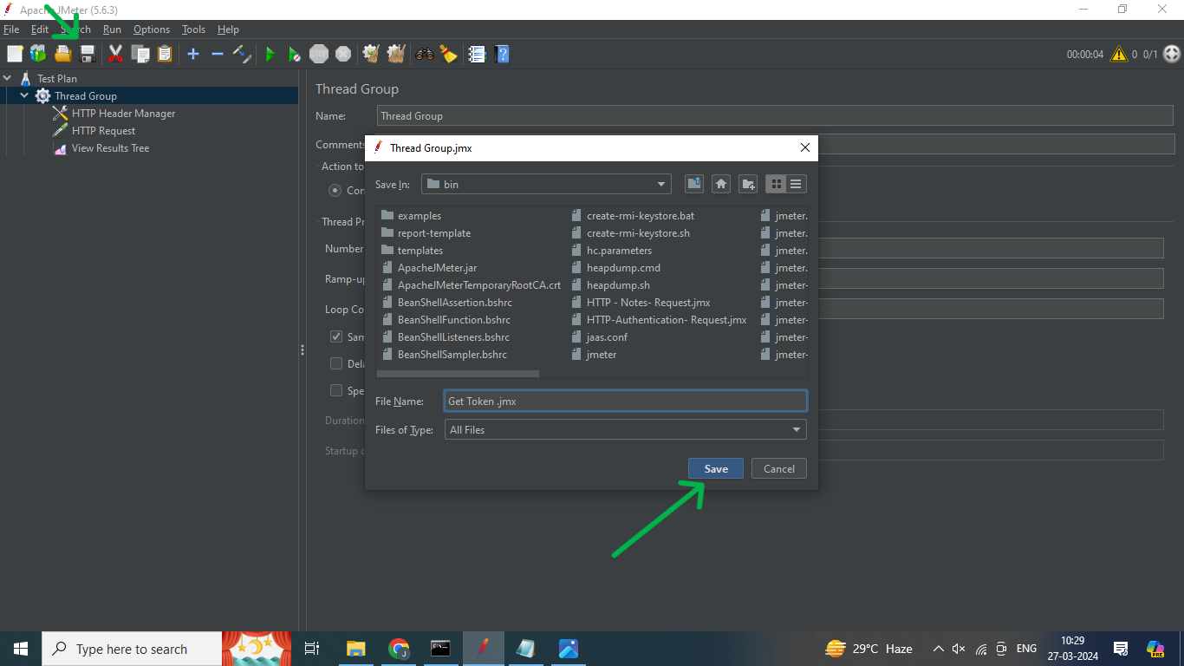

* **Finally Get the API Tokens.**

